Straight Boundary
# Source: AI Source: Provided by: [Data Path: Persons Table -> ID Column: 1, Name_En Column: Motasem Essam] -> From: [ChatGPT] on [7/25/2026]
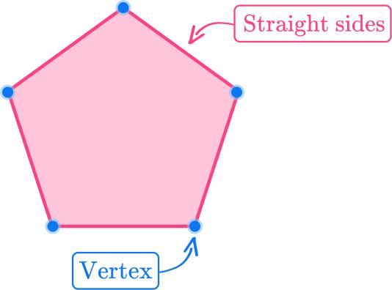
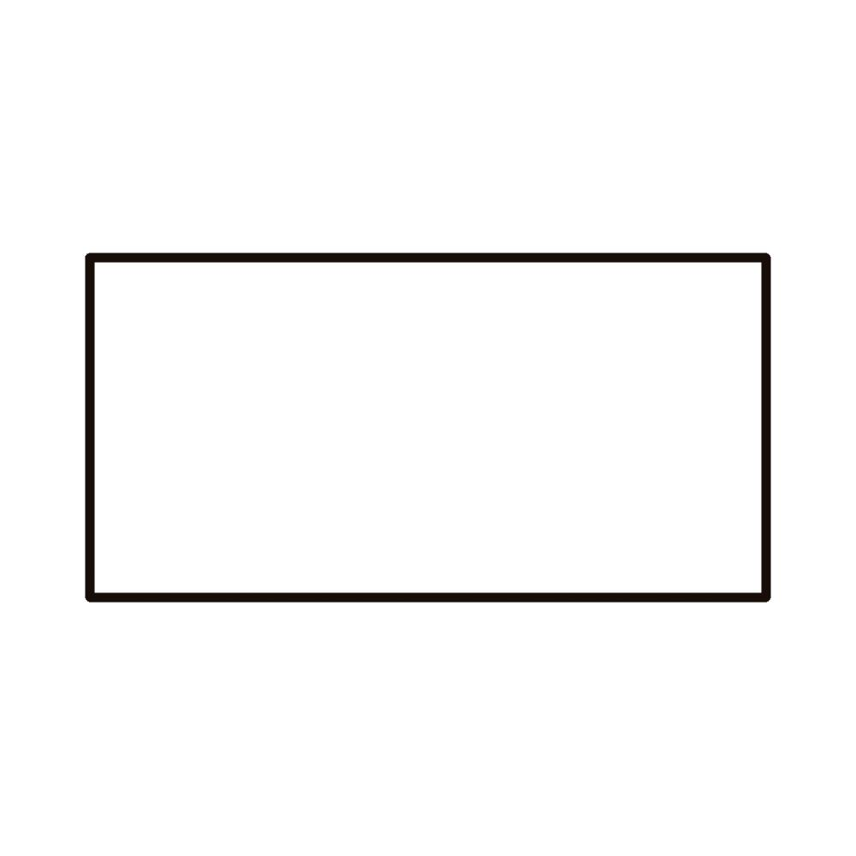
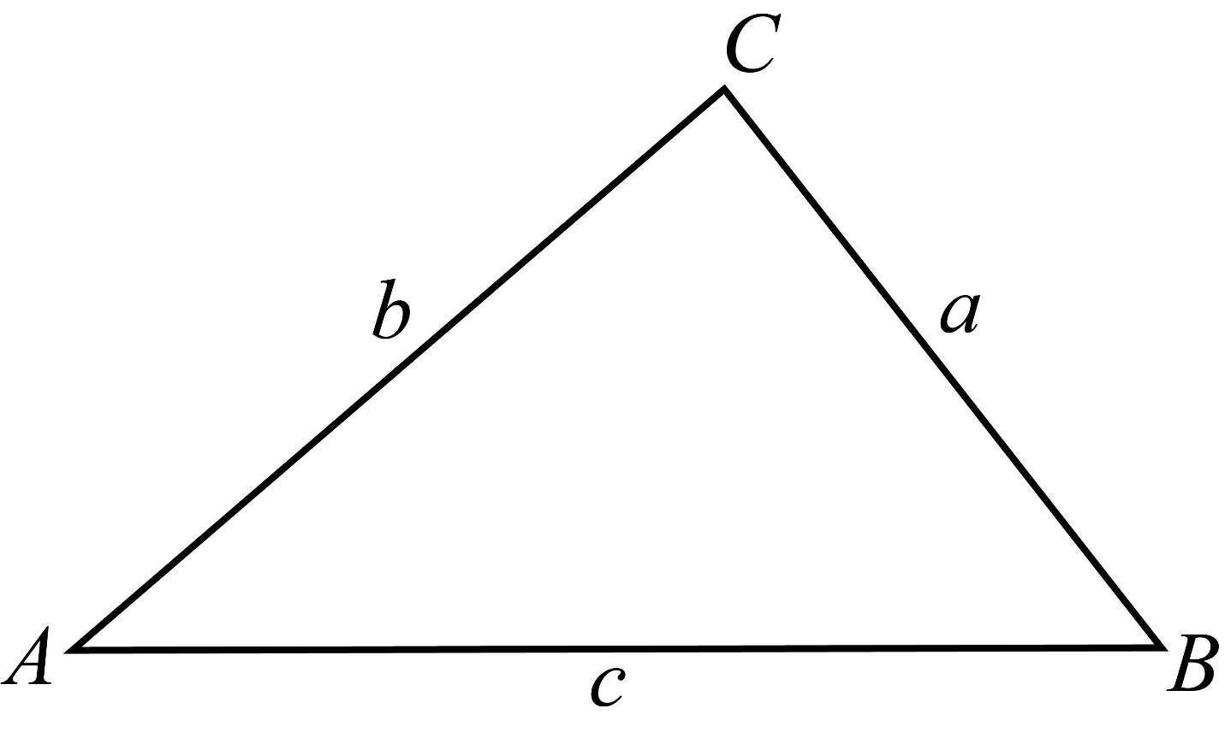
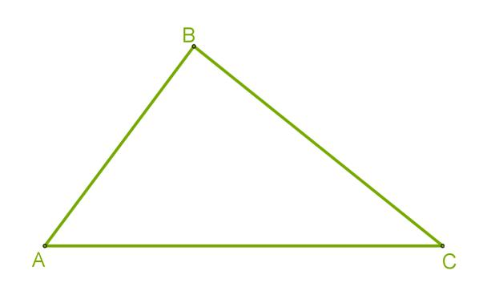

Definition
# Source: AI Source: Provided by: [Data Path: Persons Table -> ID Column: 1, Name_En Column: Motasem Essam] -> From: [ChatGPT] on [7/25/2026]
A Straight Boundary is a boundary composed entirely of straight line segments, rays, or lines, without any curved portions. It forms the edge or limit of a geometric figure using only straight geometric elements.
A straight boundary may be:
- Open, such as a single line segment.
- Closed, such as the boundary of a polygon.

Characteristics
# Source: AI Source: Provided by: [Data Path: Persons Table -> ID Column: 1, Name_En Column: Motasem Essam] -> From: [ChatGPT] on [7/25/2026]
A straight boundary:
- Is made entirely of straight geometric objects.
- Contains no curved sections.
- May be open or closed.
- Can consist of one or more connected line segments.
- Has length but no thickness.
- May enclose a bounded region if it is closed.

Illustration

Straight Closed Boundary (Rectangle)
# Source: AI Source: Provided by: [Data Path: Persons Table -> ID Column: 1, Name_En Column: Motasem Essam] -> From: [ChatGPT] on [7/25/2026]
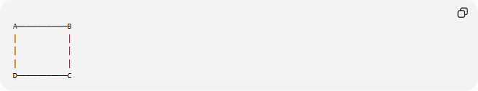
A────────────B
│ │
│ │
│ │
D────────────C
All four sides are straight line segments.

Straight Open Boundary (Line Segment)
# Source: AI Source: Provided by: [Data Path: Persons Table -> ID Column: 1, Name_En Column: Motasem Essam] -> From: [ChatGPT] on [7/25/2026]
A────────────B
This is a straight boundary but not a closed one.

Mathematical Representation
# Source: AI Source: Provided by: [Data Path: Persons Table -> ID Column: 1, Name_En Column: Motasem Essam] -> From: [ChatGPT] on [7/25/2026]
A straight boundary is represented by straight geometric objects such as:
Line segment:
$$\overline{AB}$$
Ray:
$$\overset{→}{AB}$$
Line:
$$\overset{↔}{AB}$$
Polygon boundary:
$$\overline{AB}+\overline{BC}+\overline{CD}+⋯$$

Examples
# Source: AI Source: Provided by: [Data Path: Persons Table -> ID Column: 1, Name_En Column: Motasem Essam] -> From: [ChatGPT] on [7/25/2026]
Example 1 – Triangle
A triangle has a straight boundary consisting of three line segments.
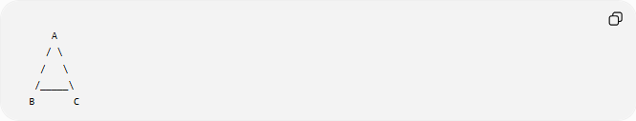
A
/ \
/ \
/_____\
B C

Example 2 – Square
The square boundary consists of four equal straight line segments.

Example 3 – Pentagon
The boundary is made of five connected straight edges.

Example 4 – Single Line Segment
A line segment itself is a straight boundary, although it does not enclose a region.

Properties
# Source: AI Source: Provided by: [Data Path: Persons Table -> ID Column: 1, Name_En Column: Motasem Essam] -> From: [ChatGPT] on [7/25/2026]
1. Straight Edges Only
Every portion of the boundary is linear.

2. No Curvature
There are no arcs, circles, or curved edges.

3. Finite or Infinite
A straight boundary may consist of:
- Finite line segments.
- Rays.
- Infinite lines.

4. May Be Open or Closed
Examples:
Open:
────────────
Closed:
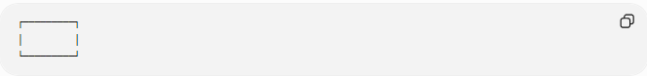
┌─────────┐
│ │
└─────────┘

Real-World Examples
# Source: AI Source: Provided by: [Data Path: Persons Table -> ID Column: 1, Name_En Column: Motasem Essam] -> From: [ChatGPT] on [7/25/2026]
Straight boundaries include:
- Walls of a room.
- Rectangular windows.
- Building edges.
- Fences.
- Property lines.
- Chessboards.
- Books.
- Tables.
- Parking spaces.

Applications
# Source: AI Source: Provided by: [Data Path: Persons Table -> ID Column: 1, Name_En Column: Motasem Essam] -> From: [ChatGPT] on [7/25/2026]
Straight boundaries are used in:
- Plane Geometry
- Coordinate Geometry
- Analytic Geometry
- Engineering
- Architecture
- Construction
- Surveying
- CAD (Computer-Aided Design)
- GIS (Geographic Information Systems)
- Computer Graphics

Advantages
# Source: AI Source: Provided by: [Data Path: Persons Table -> ID Column: 1, Name_En Column: Motasem Essam] -> From: [ChatGPT] on [7/25/2026]
Studying straight boundaries helps to:
- Compute perimeter.
- Define polygons.
- Simplify geometric proofs.
- Model engineering structures.
- Analyze coordinate geometry.

Limitations
# Source: AI Source: Provided by: [Data Path: Persons Table -> ID Column: 1, Name_En Column: Motasem Essam] -> From: [ChatGPT] on [7/25/2026]
A straight boundary:
- Cannot represent curved objects accurately.
- May require many small segments to approximate curves.
- Is unsuitable for naturally curved shapes such as circles.

Comparison with Other Boundary Types
# Source: AI Source: Provided by: [Data Path: Persons Table -> ID Column: 1, Name_En Column: Motasem Essam] -> From: [ChatGPT] on [7/25/2026]
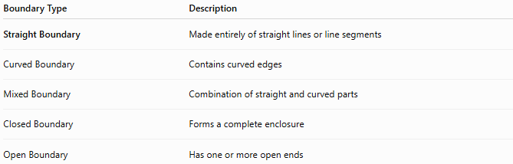
Boundary Type | Description
Straight Boundary | Made entirely of straight lines or line segments
Curved Boundary | Contains curved edges
Mixed Boundary | Combination of straight and curved parts
Closed Boundary | Forms a complete enclosure
Open Boundary | Has one or more open ends

Key Points
# Source: AI Source: Provided by: [Data Path: Persons Table -> ID Column: 1, Name_En Column: Motasem Essam] -> From: [ChatGPT] on [7/25/2026]
- A Straight Boundary consists only of straight geometric objects.
- It may be:
  - Open.
  - Closed.
- Common examples include:
  - Triangles.
  - Rectangles.
  - Squares.
  - Polygons.
- Straight boundaries are fundamental for defining polygonal figures.

Conclusion
# Source: AI Source: Provided by: [Data Path: Persons Table -> ID Column: 1, Name_En Column: Motasem Essam] -> From: [ChatGPT] on [7/25/2026]
A Straight Boundary is a boundary formed entirely from straight geometric elements such as line segments, rays, or lines, with no curved portions. It may be open or closed and serves as the defining edge of many geometric figures, particularly polygons. Straight boundaries are fundamental in plane geometry, coordinate geometry, analytic geometry, engineering, architecture, construction, surveying, CAD, GIS, and computer graphics, where they are used to define shapes, calculate perimeters, construct models, and represent precise geometric structures.

